Report about best devices in PC, best operating system and suitable programming languages.
System Name: Software Project Management System
- Best Devices
Servers: Required high performance Server to manage large amount of Projects and Tasks
Workstations: Devices must be high performance CPU like Intel Core i7 and 16 ddr4 RAM for Developer to Coding and Project Manager to Manage like hp Z Book or DELL Inspiron

- Best Operating System
Windows: most used for Software Project Management Systems and the best choice
Linux: good choice for Security, Stability and Customization
MacOS: best User Interface and User – Friendly the best choice if Project Manager or Developer uses APPLE Devices like MacBook

- Suitable Programming Languages
Java:
C#:
Python:
JavaScript:

Design of an integrated system (Class diagram)

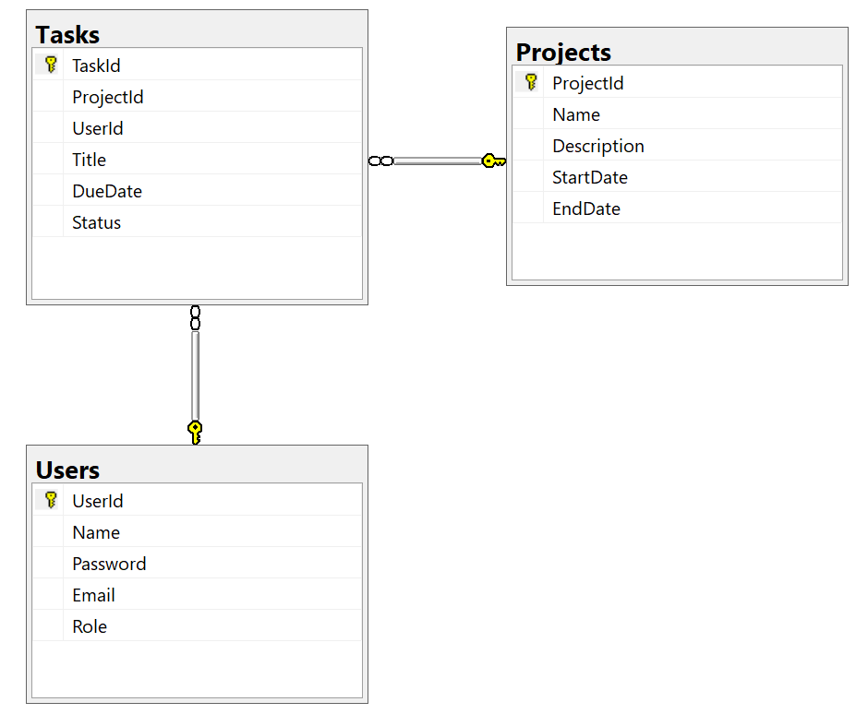

Testing
Test case ID | Test case description | Test Steps | Test Data | Expected Result | Actual Result | Pass/Fail
1 | Click login without enter Data | Click on login button | click | Show message “Invalid Data!” | Show message “Invalid Data!” | pass
2 | Login by Invalid login data | Enter Invalid Username & Password | Username = tot12y  Password = 20122008 | Show message “Invalid Data!” | Show message “Invalid Data!” | pass
3 | Login by Project Manager login data | Enter Project Manager Username & Password | Username = Mohamed  Password = 777 | Redirect to Main Projects Window | Redirect to Main Projects Window | pass
4 | Login by Developer login data | Enter Developer Username & Password | Username = Mo  Password = 777 | Redirect to My Tasks Window | Redirect to My Tasks Window | pass

